Check and Tag EC2 Instances

**To check ‘Tags’:**

1. Open the **Amazon EC2 console** from [here](https://console.aws.amazon.com/ec2/).
2. From the navigation bar, select the **Region** where the EC2 instance is located.
3. In the navigation pane, select **Instances.**
4. 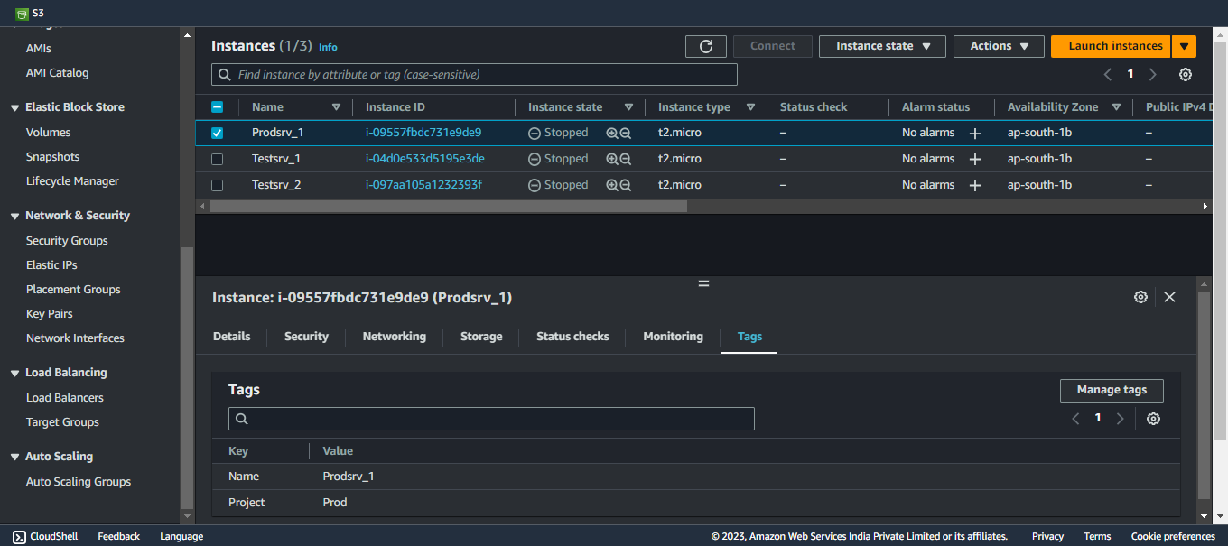Select the instance from the **Instances** and choose the **Tags** tab.
5. In the above picture, you can see that the ‘tags’ are present as Key-Value pair:

(Name: Prodsrv_1)

and

(Project: Prod)

**To create ‘Tags’:**

1. Open the **Amazon EC2 console** from [here](https://console.aws.amazon.com/ec2/).
2. From the navigation bar, select the **Region** where the EC2 instance to tag is located.
3. In the navigation pane, select **Instances.**
4. Select the instance from the **Instances** and choose the **Tags** tab.
5. 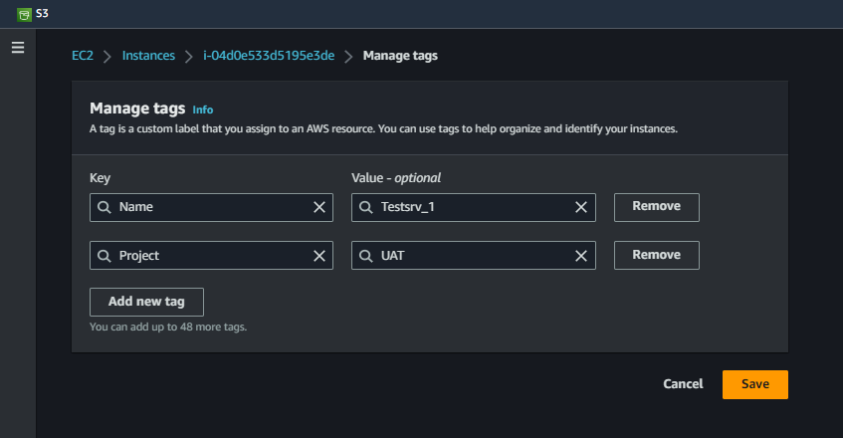Choose **Manage tags**, and then choose **Add new tag**. Enter the key and value for the tag. Choose **Add new tag** again for each additional tag to add.
6. For this project, you must make sure that one of the **Tag: Value** pairs should be **Project: UAT**.
7. When you are finished adding tags, choose **Save**.

**With the EC2 instances tagged and all set, you are now ready to proceed to the next step. Happy documenting!**